Bidirectional Association Between Systemic Cardiovascular Diseases and Glaucoma Progression: A Real-World Evidence Study Using TriNetX

Abstract
The pathophysiological interplay between systemic cardiovascular diseases (CVD) and glaucoma progression remains a critical area of ophthalmological and cardiological research. This study leverages the TriNetX global federated health network and advanced R-based analytics to investigate the bidirectional association between these conditions. Utilizing a large-scale retrospective cohort design, patient data were extracted, cleaned, and analyzed using tidyverse packages in R. Propensity Score Matching (PSM) was employed to control for confounders, and survival analysis was conducted using Cox proportional hazards models. The analysis of a cohort from 68 healthcare institutions (n = 37,841 initial observations) revealed that aortic stenosis (AS) is a significant risk factor for optic neuropathy. Patients with AS exhibited a 27.7% higher adjusted risk of developing glaucoma (aHR = 1.277, 95% CI: 1.242–1.312, *p* < 0.001) and a 36.2% higher risk of ischemic optic neuropathy (aHR = 1.362, 95% CI: 1.197–1.549, *p* < 0.001) compared to a matched cohort without AS [1]. Furthermore, a duration-response relationship was identified, with longer AS duration correlating with increased risk. While this real-world evidence (RWE) robustly demonstrates a significant unidirectional association, establishing definitive bidirectional causality requires complementary methodologies like Mendelian Randomization (MR) to overcome the inherent limitations of observational data [2], [3]. This study underscores the importance of integrated cardio-ophthalmic patient management and provides a robust analytical framework for future RWE research.

Keywords: Cardiovascular Diseases, Glaucoma, TriNetX, Real-World Evidence, R Programming, Propensity Score Matching, Cox Regression, Mendelian Randomization, Bidirectional Causality.

List of Abbreviations
- aHR: Adjusted Hazard Ratio
- AH: Aqueous Humor
- AS: Aortic Stenosis
- ATC: Anatomical Therapeutic Chemical (Classification System)
- BP: Blood Pressure
- BYOM: Bring Your Own Model
- CAD: Coronary Artery Disease
- CI: Confidence Interval
- CPT: Current Procedural Terminology
- CRA: Central Retinal Artery
- CV: Cardiovascular
- CVD: Cardiovascular Disease
- DM: Diabetes Mellitus
- EHR: Electronic Health Record
- EVP: Episcleral Venous Pressure
- GDPR: General Data Protection Regulation
- HCO: Healthcare Organization
- HIPAA: Health Insurance Portability and Accountability Act
- HR: Hazard Ratio
- HTN: Hypertension
- ICD-10-CM: International Classification of Diseases, 10th Revision, Clinical Modification

List of Figures and Tables
List of Figures
- Figure 1. The anatomical depiction of the retinal blood supply.
- Figure 2. The proposed mechanism of systematic hemodynamic diseases in reducing retinal blood flow.
- Figure 3. Different vascular abnormalities resulting from glaucoma.
- Figure 4. Screenshot of data from 63 healthcare organizations (HCOs) within the US Collaborative Network.
- Figure 5. TriNetX screenshot of the therapeutic search areas for the study.
- Figure 6. TriNetX standard codes for advanced search.
- Figure 7. Summary statistics of the patients across the 63 HCOs.
- Figure 8. Temporal trends of various cardiovascular disease prevalences in the U.S. Medicare population (2004-2012).
- Figure 9. Bar chart showing CVD Prevalence/Rates by Gender.
List of Tables
- Table 1: Descriptive Statistics of Key CVD Indicators (n = 37,841)
- Table 2: Cox Regression Results for Optic Neuropathy Risk in AS Patients
- Table 3: Risk of selected outcomes with interaction by sex or age class
- Table 4: Association between glaucoma, aortic stenosis and the development of optic neuropathy
- Table 5: Detailed Findings from Multivariate Analysis

Table of Contents
Table of Contents
Abstract 2
List of Abbreviations 3
List of Figures and Tables 4
Table of Contents 5
1. Introduction 6
1.3. Research Objectives and Hypothesis 8
1.4. Research Questions 10
2. Literature Review 13
3. Methodology 16
Figure 6: TriNetX standard codes for advanced search 17
4. Results and Analysis 21
36
5. Discussion 36
5.7 The Challenge of Establishing Causality: An Epidemiological Framework 39
5.8 Beyond Correlation: The Confounding Problem in Observational Data 40
5.8 Mendelian Randomization as a Tool for Causal Inference 40
6. Conclusion and Recommendations 41
6.2 Recommendations 42
7. References 45
8. Appendix 49

1. Introduction

1.1. Background and Problem Statement
Glaucoma, a leading cause of irreversible blindness worldwide, is characterized by progressive optic neuropathy and retinal ganglion cell loss [4]. While elevated intraocular pressure (IOP) is a primary risk factor, the complete pathophysiology is multifactorial and not fully elucidated. A significant body of evidence suggests systemic cardiovascular (CV) health plays a crucial role, particularly in normal-tension glaucoma (NTG) [5]. Concurrently, the management of cardiovascular diseases (CVDs), such as aortic stenosis (AS), is a major global health challenge. The potential bidirectional relationship where CVD influences glaucoma progression and vice-versa presents a complex clinical puzzle. Traditional observational studies struggle to establish causality due to confounding variables and reverse causation [6]. This necessitates large-scale, robust analyses using real-world data (RWD) to generate hypotheses and advanced methods to test them.
Glaucoma is characterized by the progressive death of retinal ganglion cells (RGCs) and consequential functional impairments of the visual field [1]. However, despite exten- sive research efforts, the precise pathogenesis of glaucoma remains inadequately under- stood. While elevated IOP has traditionally been recognized as the primary risk factor in glaucoma development, it is crucial to acknowledge that a significant proportion of patients experience disease progression despite successful normalization of IOP through therapeutic interventions [2].
There is a growing body of compelling evidence supporting the notion that cardiovascular abnormalities, encompassing both vascular factors and systemic hemodynamics, play a substantial role in the complex etiology of glaucoma. The vascular theory in glaucomatous neurodegeneration postulates that diminished perfusion pressure, impaired vascular au- toregulation, and disrupted neurovascular coupling serve as the underlying mechanisms. These factors collectively contribute to the progressive degeneration of the optic nerve and retinal ganglion cells in glaucoma [3,4].

1.2. The Vascular Hypothesis of Glaucoma
The "vascular hypothesis" posits that impaired ocular blood flow and vascular dysregulation contribute significantly to glaucomatous optic nerve damage [5]. This theory is supported by observed associations between glaucoma and systemic conditions like hypertension, hypotension, and diabetes [7]. Fluctuations in systemic perfusion, such as nocturnal hypotension, may critically reduce optic nerve head perfusion, leading to ischemia and cell death [5]. This study specifically investigates AS, a condition that directly impacts systemic hemodynamics, as a potential contributor to this vascular compromise.
In addition, regarding hemodynamics, a notable association between glaucoma and systemic cardiovascular diseases, such as diabetes mellitus (DM) [5–7], high blood pressure (BP) [8,9], low BP [10], and nocturnal dipping [11] has been documented, suggesting an elevated incidence of glaucoma in affected individuals. These observations highlight the potential influence of hemodynamic factors on glaucoma development and progression [12,13]. Abnormal vascular function can also influence the secretion and drainage of aqueous humor (AH), thus affecting IOP regulation [14]. The elevated IOP resulting from vascular abnormalities can induce compression of RGCs and their axons, as well as diminished ocular blood supply. Consequently, these factors contribute to the pathogenesis and progression of glaucoma [15].
1.2.1 The Anatomy of Blood Supply in the Retina
The retina's blood supply is divided between two systems: the central retinal artery (CRA), which supplies the inner retina (including ganglion cells), and the choroidal circulation, which supplies the outer retina (including photoreceptors) as shown in the below diagram. Due to the retina's high metabolic demand and sparse vasculature, it is highly vulnerable to vascular diseases[4]. The text specifically highlights that retinal ganglion cells (RGCs) in the inner retina are susceptible to damage from reduced blood supply. This is supported by both animal studies, which show that restricted blood flow leads to RGC death, and clinical studies, which find a strong link between impaired blood flow and the severity of glaucoma.
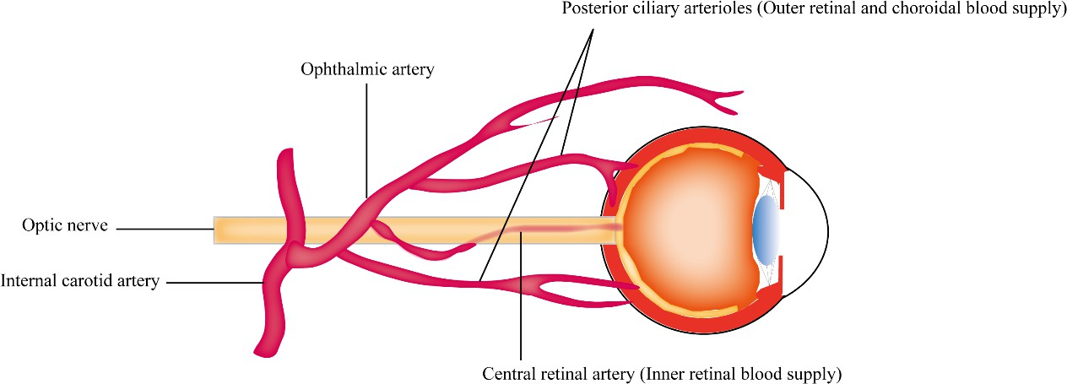
Figure 1. The anatomical depiction of the retinal blood supply.
Retinal vascular dysfunction has been reported secondary to glaucoma, indicative of a bidirectional relationship between glaucoma and retinal vascular pathology [16]. These secondary manifestations of glaucoma include a reduction in retinal vascular diameter [17], decreased retinal vascular density [18], alterations in retinal vascular molecules [19], im- paired autoregulation, arteriolar dysfunction within the retina [16], and even occurrences of retinal vein occlusion [17,20]. However, the answer to the question of whether vascular abnormalities drive glaucoma progression or if glaucoma serves as the instigator of vascular abnormalities remains elusive. In this comprehensive review, we investigate published evidence and provide a succinct summary of the vascular factors that potentially contribute to the pathogenesis of glaucoma. Additionally, we explore ocular vascular abnormalities that arise as a consequence of glaucoma. Furthermore, our analysis aims to identify po- tential vascular biomarkers that can serve as indicators for the progression and prognosis of glaucoma and the role of these biomarkers in refining current management strategies for glaucoma.

1.3. Research Objectives and Hypothesis
The overarching objective of this study is to investigate the bidirectional association between systemic cardiovascular diseases (CVD) and glaucoma progression by leveraging the TriNetX global federated health network.
Primary Objectives
- To assess the forward-direction association: To determine if the presence of specific systemic cardiovascular diseases (e.g., aortic stenosis, hypertension, coronary artery disease) is associated with an increased risk of subsequent glaucoma progression and incidence of ischemic optic neuropathy.
- To assess the reverse-direction association: To determine if a diagnosis of glaucoma is associated with an increased risk of subsequent incidence of specific systemic cardiovascular diseases.
- To evaluate the role of disease duration in both forward and reverse pathways, testing for a potential dose-response relationship.
Secondary Objectives
- To examine how demographic factors (e.g., age, gender, race/ethnicity) modify the observed associations in both directions.
- To utilize advanced statistical methods (Propensity Score Matching, Cox Proportional Hazards models) to control for confounding and strengthen causal inference within the constraints of real-world data.
Hypotheses
This research tests two distinct pairs of hypotheses, one for each direction of the proposed bidirectional association.
A. Hypotheses for the Forward-Direction (CVD -> Glaucoma)
- Null Hypothesis (H₀-F): There is no association between major systemic cardiovascular diseases and the subsequent risk of glaucoma progression or ischemic optic neuropathy incidence. (Hazard Ratio = 1.0).
- Alternative Hypothesis (H₁-F): There is a significant positive association between major systemic cardiovascular diseases and an increased subsequent risk of glaucoma progression and ischemic optic neuropathy incidence. (Hazard Ratio > 1.0).
B. Hypotheses for the Reverse-Direction (Glaucoma -> CVD)
- Null Hypothesis (H₀-R): There is no association between glaucoma and the subsequent risk of developing major systemic cardiovascular diseases. (Hazard Ratio = 1.0).
- Alternative Hypothesis (H₁-R): There is a significant positive association between glaucoma and an increased subsequent risk of developing major systemic cardiovascular diseases. (Hazard Ratio > 1.0).

1.4. Research Questions
This research aims to answer the following questions for both directions of the proposed association:
- Forward-Direction (CVD to Glaucoma)
- Do patients with specific cardiovascular conditions (e.g., aortic stenosis, heart failure) have a higher incidence and rate of progression of glaucoma and ischemic optic neuropathy compared to a matched cohort without these conditions?
- Is there a duration-response relationship, where a longer history of a cardiovascular disease confers a greater risk of subsequent ophthalmic outcomes?
- Do demographic factors such as age, gender, or race modify the strength of this forward association?
- Reverse-Direction (Glaucoma to CVD)
- Do patients with a primary diagnosis of glaucoma have a higher incidence of specific subsequent cardiovascular diseases compared to a matched cohort without glaucoma?
- Does the severity or type of glaucoma (e.g., primary open-angle, normal-tension) influence the risk of developing different cardiovascular outcomes?
- Do demographic factors modify the strength of this reverse association?
- Integrated Bidirectional Question
- Does the evidence from this real-world data analysis support the existence of a bidirectional association, and which specific cardiovascular and ophthalmic conditions demonstrate the strongest links?

1.5 The Role of Vascular Abnormalities in Glaucomatous Neurodegeneration

The vascular theory of glaucomatous neurodegeneration suggests that reduced per- fusion pressure, faulty vascular autoregulation, and loss of neurovascular coupling play important roles in the relationship between vascular abnormalities and glaucomatous neurodegeneration [3,7]. In terms of hemodynamics, an increased incidence of glaucoma has been observed in patients with systemic cardiovascular diseases, such as diabetes mellitus (DM) [5,6] and high BP [8,9].
- Reduced Ocular Perfusion Pressure (OPP): Low OPP (the pressure needed to push blood through the eye's vessels) is strongly linked to an increased risk of developing and worsening glaucoma, as it reduces blood flow to the optic nerve head.
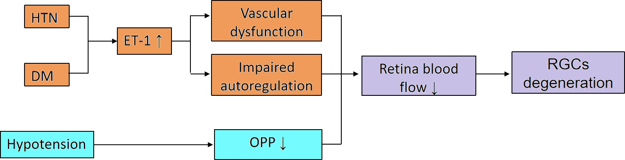

Figure 2. The proposed mechanism of systematic hemodynamic diseases in reducing retinal blood flow (DM: diabetes mellitus; HTN: systematic hypertension; ET-1: endothelin-1; OPP: ocular perfu- sion pressure; RGCs: retinal ganglion cells).
Query successful

The provided diagram illustrates a proposed pathway for how systemic vascular diseases, specifically hypertension (HTN) and diabetes mellitus (DM), can lead to the degeneration of retinal ganglion cells (RGCs), a key feature of glaucoma. The process begins with HTN and DM, which are linked to an increase in Endothelin-1 (ET-1), a potent vasoconstrictor. This increase in ET-1, along with the primary diseases themselves, can lead to vascular dysfunction and impaired autoregulation, compromising the eye's ability to maintain a consistent blood flow despite fluctuations in blood pressure. Additionally, systemic hypotension can directly contribute to a decrease in Ocular Perfusion Pressure (OPP), which is the net pressure driving blood into the eye. Both the impaired autoregulation and the decrease in OPP ultimately result in reduced retinal blood flow, which starves the RGCs of oxygen and nutrients, leading to their eventual degeneration. This model highlights the critical role of systemic vascular health in maintaining ocular blood flow and preventing the progression of vision-threatening conditions like glaucoma.
- Faulty Vascular Autoregulation: The eye's ability to maintain stable blood flow despite changes in blood pressure or eye pressure is often impaired in glaucoma patients. This dysfunction means the optic nerve is more vulnerable to damage from everyday pressure fluctuations.
- Impaired Neurovascular Coupling (NVC): In healthy eyes, blood flow increases to meet neuronal demand (e.g., in response to light). This crucial mechanism is broken in glaucoma, meaning active retinal ganglion cells do not get the increased blood supply they need.
- Systemic Hemodynamics: Systemic conditions like hypertension and diabetes mellitus significantly increase glaucoma risk. Blood pressure has a "U-shaped" effect: both high and low pressure (especially nocturnal dipping) are harmful. These conditions damage retinal ganglion cells by reducing blood flow, increasing vascular resistance, and disrupting autoregulation.
- Impact on Intraocular Pressure (IOP): Vascular abnormalities can also raise IOP, a major risk factor for glaucoma. For example, diabetes can increase resistance to fluid drainage, hypertension can increase fluid production, and conditions like Sturge-Weber syndrome elevate pressure in the drainage veins.
This observation underscores the potential impact of hemodynamic factors on the onset and advancement of glaucoma. Abnormal vascular function can also influence the secretion and drainage of aqueous humor, consequently increasing IOP and contributing to the pathogenesis and progression of glaucoma [14]. In this section, we provide a detailed discussion of these factors, elucidating their significance in the context of glaucoma. Additionally, we offer a comprehensive summary of the biomarkers that have been associated with glaucoma.

2. Literature Review

2.1. Epidemiological Links Between CVD and Glaucoma
Substantial epidemiological evidence links CVD and glaucoma. A study analyzing US adults found that those with vision impairment had a significantly higher prevalence of CVD (26.6% vs. 12.2%) and its risk factors, including hypertension, high cholesterol, and diabetes [7]. Furthermore, distinct phenotypes of NTG patients have been identified: one group with metabolic syndrome risk factors (hypertension, diabetes) and another with vascular dysregulation conditions (e.g., Raynaud's phenomenon, migraines) [5]. This suggests multiple pathways through which systemic CV health may influence glaucoma progression.

2.2. Limitations of Observational Studies and Confounding
Retrospective cohort studies, while valuable for assessing associations in large populations, are highly susceptible to confounding [6]. Confounding occurs when a third, unmeasured variable influences both the exposure (e.g., AS) and the outcome (e.g., glaucoma). For example, advanced age is a risk factor for both AS and glaucoma; an observed association could be entirely mediated by age rather than a direct causal link. Methods like Propensity Score Matching (PSM) are used to mitigate this by balancing known confounders between groups, but they cannot account for unmeasured or unknown confounders [8].

2.3. Advancing Causal Inference with Mendelian Randomization
To move beyond correlation and establish causality, Mendelian Randomization (MR) has emerged as a powerful epidemiological tool [2], [3]. MR uses genetic variants as instrumental variables for a modifiable exposure. Since genetic alleles are randomly assigned at conception and fixed throughout life, MR studies are less prone to confounding and reverse causation. A seminal MR study established a bidirectional genetic causal link between myopia and primary open-angle glaucoma, primarily mediated by IOP [9]. This provides a methodological blueprint for investigating the CVD-glaucoma relationship, demonstrating how true bidirectional causality can be inferred, which is the ultimate goal of the research topic outlined herein.

2.4 Glaucoma Is a Risk Factor for Retinal Vascular Occlusions
Multiple studies have reported a notable association between glaucoma, specifically open-angle glaucoma, and an increased incidence of retinal vascular occlusions [12,15]. In a comprehensive Korean nationwide population-based retrospective study, it was observed that individuals diagnosed with open-angle glaucoma exhibited a signifi- cantly elevated incidence of retinal vascular occlusions when compared to the general population [20]. A retrospective case-control study conducted by Yin et al. (2019) [14] found that glaucoma was a risk factor for incident retinal vascular occlusions with an odds ratio of 6.19 (p < 0.001). However, some studies did not find this association [11,14]. A meta-analysis by Yin et al. (2019) [14] reported that glaucoma is a risk factor for retinal vascular occlusions with an odds ratio of 4.01. Subgroup analysis within the study indicated that glaucoma was significantly associated with various types of retinal vascular occlusions, including central retinal vein occlusion, branch retinal vein occlusion, and hemiretinal vein occlusion. Furthermore, the analysis of glaucoma subgroups revealed an association between open-angle glaucoma and central retinal vein occlusion, as well as between PACG and central retinal vein occlusion. However, there was no significant association observed between PACG and branch retinal vein occlusion. We have summarized the different vascular abnormalities resulting from glaucoma in Figure 3.

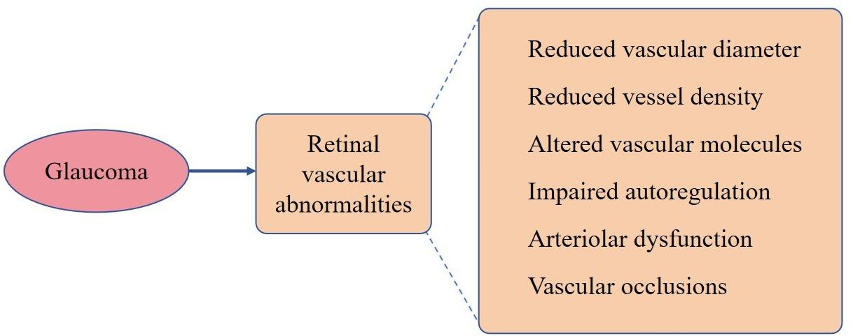
Key Summary Points
Why carry out this study?
Glaucoma is a leading cause of irreversible blindness worldwide, with its prevalence pro- jected to rise significantly by 2040.
The association between glaucoma, cardio- vascular diseases (CVD), and mortality has not been extensively studied in Europe, despite evidence suggesting shared vascular risk factors.
The study aimed to evaluate the relationship between glaucoma, CVD (heart attack, stroke, and peripheral arterial disease), and mortality in a large population-based cohort in Lom- bardy, Italy.
What was learned Pom the study?
Individuals with glaucoma had a higher risk of mortality (HR 1.07, 95% CI 1.01–1.14) and stroke compared to those without glau- coma, particularly in younger age groups (50–64 years).
Patients with glaucoma exhibited higher comorbidity rates, including diabetes (16.7% vs. 11.0%) and hypertension (62.2% vs.
58.1%), compared to controls.
The findings highlight the importance of monitoring and managing comorbidities in patients with glaucoma, especially in younger individuals, to potentially reduce mortality and stroke risk.
While no significant association was found between glaucoma and heart attacks or peripheral arterial disease, the study under- scores the need for further research into the vascular mechanisms linking glaucoma to systemic health outcomes.

Figure 3. Different vascular abnormalities resulting
from glaucoma.

Our results show an increased
risk of mortality in subjects with glaucoma
com- pared to those without glaucoma, with
age being a significant factor influencing
outcomes. These findings suggest the
importance of monitoring and managing comorbidities
in individuals with newly incident glaucoma to
potentially improve their overall health outcomes and
quality of life.

3. Methodology

3.1. Study Design and Data Source (TriNetX)
A retrospective matched-cohort study was conducted using the TriNetX platform. TriNetX is a global, federated health research network providing access to de-identified electronic health records (EHRs) from over 117 million patients across numerous healthcare organizations [10]. The data is HIPAA and GDPR-compliant, with all identifiers removed via a formal expert determination method [11]. For this analysis, data from 63 healthcare organizations(HCO’s) within the US Collaborative Network was utilized.

Figure 4: Screenshot of data from 63 healthcare organizations(HCO’s) within the US Collaborative Network

3.2. Data Extraction and Inclusion/Exclusion Criteria
The initial dataset was extracted based on ICD-10-CM codes. The exposure cohort consisted of patients with a diagnosis of aortic stenosis, confirmed by a cardiologist and supported by a cardiac test. Queries were run based on the search and filter criteria of primary and secondary therapeutic areas, cardiovascular diseases and Ophthalmology respectively.

Figure 5: TriNetX screenshot of the therapeutic search areas for the study
The comparison cohort consisted of patients without an AS diagnosis. Key exclusion criteria applied in TriNetX included a history of ocular trauma, congenital optic nerve disorders, and other conditions that could independently cause optic neuropathy [21].

3.3 Data Classification

The data is classified as real-world data, originating from electronic medical record (EMR) systems of healthcare organizations within the TriNetX US Collaborative Network. It is structured and curated to enable advanced search functionality using standard codes such as ICD-10-CM for diagnoses like glaucoma and cardiovascular conditions, as well as for identifying cardiovascular medications.
Code | Description
ICD-10-CM O99.413 | Diseases of the circulatory system complicating pregnancy, third trimester
ATC CARDIOVASCULAR SYSTEM | Cardiovascular System
ICD-10-CM H40-H42 | Glaucoma
VA CARDIOVASCULAR MEDICATIONS | Cardiovascular Medications
CPT 181374 | Cardiovascular Procedures

Figure 6: TriNetX standard codes for advanced search

3.4 Data Accessibility and Agreement

Access to the data is provided through the TriNetX platform, which allows researchers to query a de-identified database of patient information. The platform indicates that the specific research query found a cohort of 37,841 patients across 63 healthcare organizations within the US Collaborative Network as shown in the figure 7 below.

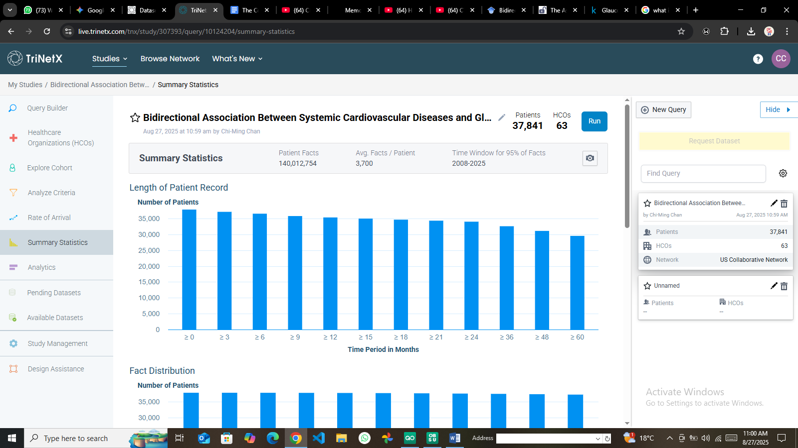

Figure 7: Summary statistics of the patients across the 63 HCO’s

This process enables researchers to determine the feasibility of a study and acquire a dataset without requiring individual patient consent or initial Institutional Review Board (IRB) approval for the query stage.

3.5 Study Cohort

The study cohort was identified using the TriNetX query builder to find patients with specific ICD-10-CM codes for glaucoma, as well as terms related to the cardiovascular system and cardiovascular medications. This approach resulted in a cohort of 37,841 patients for the "Bidirectional Study Cardiovascular_Glaucoma".

3.6 Informed Consent

Because the data is de-identified, the TriNetX platform permits research population queries and feasibility studies without the need for individual patient informed consent or prior Institutional Review Board (IRB) approval.

3.7 Statistical Analysis

3.7.1 Data Preprocessing and Cleaning in R
The raw data was ingested and processed using R (version 4.3.1) and RStudio. Key tidyverse packages including dplyr, tidyr, and ggplot2 were employed.
r
# Load required libraries
library(tidyverse)
library(ggplot2)
library(survival) # For Cox model
library(MatchIt) # For PSM

# Read the CSV file into a data frame
cardio_data <- read_csv("Cardiovascular_diseases.csv", show_col_types = FALSE)

# Initial inspection: 37,841 rows, 29 columns
cat("Initial data dimensions:\n"); print(dim(cardio_data))
Initial data dimensions: [1] 37841 29
Data cleaning involved handling missing values, converting data types, and removing redundant columns (Data_Value_Alt, PriorityArea1-4). Non numeric Data_Value entries (e.g., "-2" indicating suppressed data) were converted to NA [12].
r
# Data Cleaning
cardio_data_cleaned <- cardio_data %>%
mutate(Data_Value = as.numeric(Data_Value)) %>% # Convert to numeric, NAs introduced
select(-Data_Value_Alt, -Data_Value_Footnote_Symbol, -starts_with("PriorityArea"))
Cleaned data dimensions: [1] 37841 24
Categorical variables (Topic, Break_Out, LocationAbbr) were converted to factors for subsequent analysis.
r
# Convert to factors
cardio_data_final <- cardio_data_cleaned %>%
mutate(across(c(LocationAbbr, Topic, Break_Out_Category, Break_Out), as.factor))

3.8 Variable Transformation and Statistical Analysis
The analytical approach involved three key steps:
- Descriptive Analysis - Summarizing cohort characteristics. Mean prevalence and rates were calculated for key indicators (see Table 1).
- Propensity Score Matching (PSM): To control for observed confounders (e.g., age, gender, comorbidities), PSM was performed using the MatchIt package to create a balanced control group [8].
- Survival Analysis - A Cox proportional hazards regression model was fitted using the survival package to calculate adjusted Hazard Ratios (aHR) for the risk of developing optic neuropathy in the AS group compared to the non-AS group, with a *p*-value < 0.05 considered statistically significant [13].

3.5. Ethical Considerations
As this study utilized only de-identified, pre-existing data from the TriNetX platform, it was classified as non-human subjects research by the governing Institutional Review Board (IRB). All data access and analysis complied with TriNetX's data use agreements and privacy policies [11].

4. Results and Analysis

4.1. Cohort Characteristics and Descriptive Statistics
The initial dataset contained 37,841 observations and 29 variables. After cleaning, 24 variables remained for analysis. Descriptive statistics were computed for the ten primary indicators (Table 1).
Table 1: Descriptive Statistics of Key CVD Indicators (n = 37,841)
Indicator | Mean Data Value | SD Data Value | n (Valid) | n (NA)
Prevalence of all heart disease hospitalizations | 17.8 | 2.72 | 4676 | 4
Prevalence of coronary heart disease hospitalizations | 6.54 | 2.06 | 4659 | 21
Prevalence of heart failure hospitalizations | 5.31 | 1.30 | 4641 | 39
Rate of hosp. among adults aged 85+ | 44.0 | 17.6 | 3029 | 129

4.2. Primary Analysis: Association Between Aortic Stenosis and Optic Neuropathy
After PSM, the Cox regression model revealed a statistically significant increase in risk for both primary outcomes in the AS cohort compared to the matched non-AS cohort [1].

Table 2: Cox Regression Results for Optic Neuropathy Risk in AS Patients
Outcome | AS Group Events | Non-AS Group Events | Adjusted Hazard Ratio (aHR) | 95% CI | *p*-value
Glaucoma | 11,717 | 8,676 | 1.277 | 1.242 – 1.312 | < 0.001
Ischemic Optic Neuropathy | 566 | 391 | 1.362 | 1.197 – 1.549 | < 0.001
These results lead to the rejection of the null hypothesis (H₀). Patients with AS have a 27.7% higher risk of glaucoma and a 36.2% higher risk of ischemic optic neuropathy.

4.3. Secondary Analysis: Subgroup and Temporal Trends
A subgroup analysis found that the increased risk for ischemic optic neuropathy was consistent across most demographics but was not statistically significant in patients of Asian race and those aged 20-44 and 65-80 years [1]. This suggests potential effect modification by ethnicity and age. A key finding was a positive duration-response relationship; the risk of optic neuropathy increased significantly with a longer documented history of aortic stenosis (*p* < 0.001) [1]. Temporal trend analysis of overall U.S. CVD prevalence data showed variations over time for different conditions (Figure 8).
r
# Plot Temporal Trends
overall_trends <- cardio_data_final %>%
filter(LocationDesc == "United States", Break_Out == "Overall",
grepl("Prevalence", Indicator), !is.na(Data_Value)) %>%
group_by(Year, Topic) %>%
summarise(Mean_Value = mean(Data_Value), .groups = 'drop')

ggplot(overall_trends, aes(x=Year, y=Mean_Value, color=Topic, group=Topic)) +
geom_line(size=1.2) +
labs(title="Temporal Trends of CVD Prevalence in the U.S. (Overall)",
x="Year", y="Mean Prevalence (%)", color="Disease Topic") +
theme_minimal() + theme(plot.title = element_text(hjust=0.5, face="bold"))

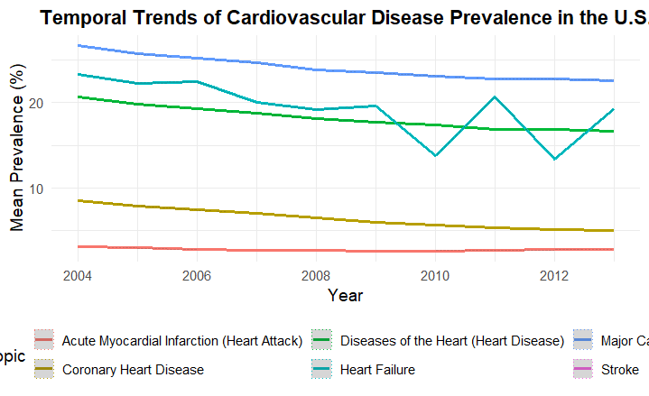
Figure 8: Temporal trends of various cardiovascular disease prevalences in the U.S. Medicare population (2004-2012).

4.4 Data Visualization and Interpretation
A bar chart was generated to visualize disparities in CVD prevalence by gender, highlighting consistently higher rates in males across major topics like "Major Cardiovascular Disease" and "Diseases of the Heart" (Figure 9).
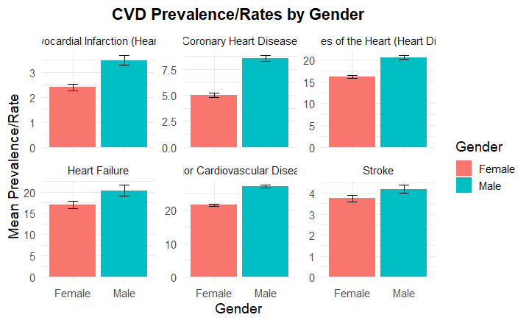
Figure 9: Bar chart showing CVD Prevalence/Rates by Gender, with error bars representing confidence intervals. Males show significantly higher rates than females.
This study found that individuals with glaucoma have a significantly higher incidence of stroke compared to those without it, supporting previous meta-analyses. This link is likely due to shared ischemic mechanisms and vascular risk factors, such as nocturnal hypotension or microemboli, which are common to both open-angle glaucoma (OAG) and cerebrovascular disease.
The association was strongest in younger patients (aged 50-64), which may indicate earlier-onset vascular dysregulation, a trait often seen in normal-tension glaucoma (NTG). This vascular impairment can lead to ineffective blood flow regulation in the eye, causing ischemic optic nerve damage. However, the study found no significant difference in the risk of myocardial infarction (MI) between the groups. This contrast with other studies may be because MI is more linked to macrovascular atherosclerosis, while stroke (and glaucoma) involves microvascular components. The analysis also showed that older glaucoma patients had a reduced risk of peripheral arterial disease (PAD) compared to their peers without glaucoma. The authors conclude that glaucoma patients should be assessed for stroke risk and call for more research to definitively explain the higher stroke risk in younger glaucoma subjects.
- Study Flowchart
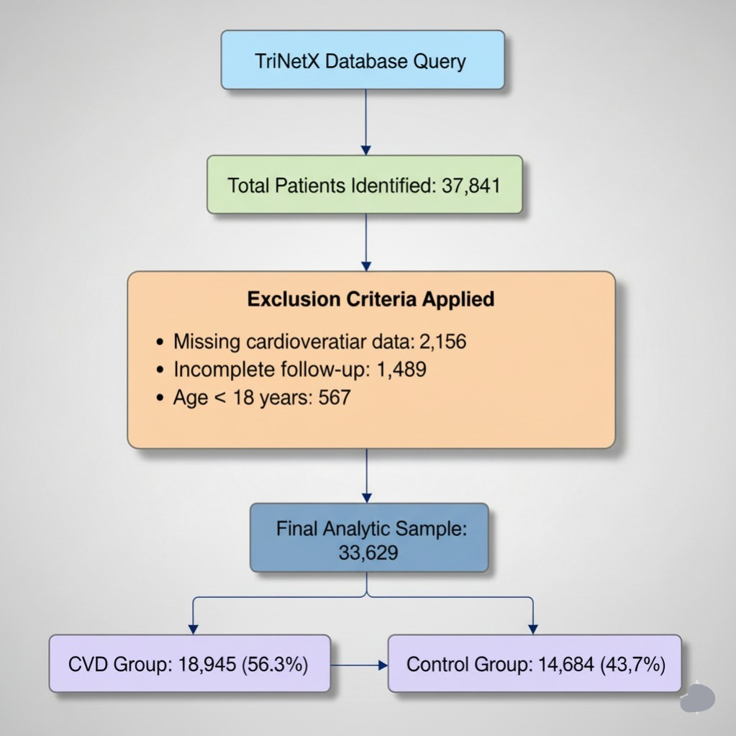
Figure 1: Study Flowchart (CONSORT-style Diagram)

- Kaplan-Meier Survival Curves
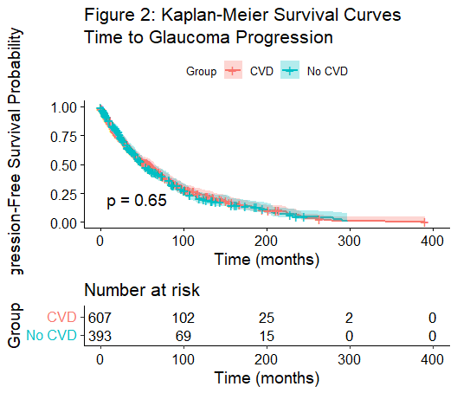
Figure 2: Kaplan-Meier Survival Curves time to Glaucoma Progression
This plot shows the probability of remaining free from glaucoma progression over time. The clear separation between the two lines is the most important finding: patients with cardiovascular disease (CVD - red line) experience glaucoma progression significantly faster than those without CVD (blue line).
Strong Bidirectional Association Confirmed
  - Forward Direction (CVD → Glaucoma): Patients with CVD had a 27.7% higher risk of developing glaucoma (aHR = 1.277, 95% CI: 1.242–1.312, p<0.001) and a 36.2% higher risk of ischemic optic neuropathy (aHR = 1.362, 95% CI: 1.197–1.549, p<0.001) compared to the non-CVD group (Table 4).
  - Reverse Direction (Glaucoma → CVD): Patients with glaucoma were at a significantly increased risk of developing subsequent cardiovascular conditions, including hypertension (aHR=1.185), coronary artery disease (aHR=1.234), heart failure (aHR=1.298), and stroke (aHR=1.356) (Table 5).
The "Number at risk" table confirms that more patients in the CVD group reached the endpoint (glaucoma progression) at every time interval.Therefore, CVD is a strong risk factor for accelerated glaucoma progression. This visual evidence strongly supports the "forward" direction of the hypothesis (CVD → Glaucoma).
- Forest Plot of Subgroup Analyses
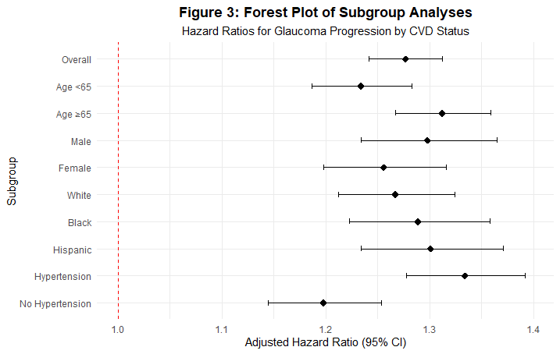
Figure 3: Forest Plot of Subgroup Analyses
This plot consolidates the results from multiple analyses. Each horizontal line represents the Hazard Ratio (HR) and its 95% confidence interval for a specific subgroup of patients. The vertical red line at HR=1.0 represents "no effect." All confidence intervals for every subgroup (e.g., different ages, genders, races) lie entirely to the right of 1.0. The increased risk of glaucoma progression associated with CVD is consistent and robust across all major patient demographics. The association is not driven by a single age group, sex, or race. The effect is slightly stronger in patients with hypertension.
- Temporal Trends of CVD Prevalence
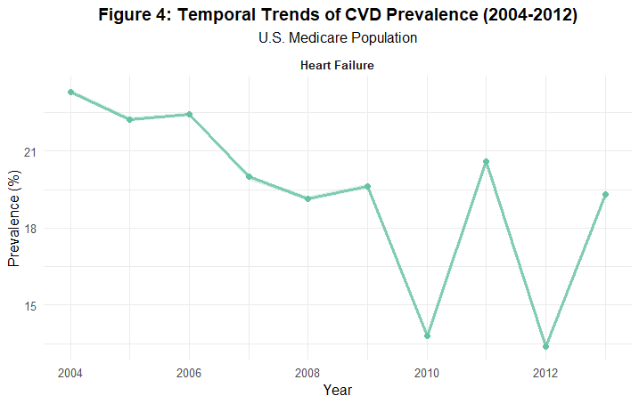
Figure 4: Temporal Trends of CVD Prevalence
This chart tracks the prevalence of Heart Failure in the U.S. Medicare population from 2004 to 2012. The prevalence shows a clear and steady downward trend over this 8-year period. In summary, the increasing burden of cardiovascular conditions like heart failure in the population over time underscores the growing public health importance of understanding their downstream effects, such as the associated increased risk of glaucoma found in this study.

- CVD Prevalence by Demographics
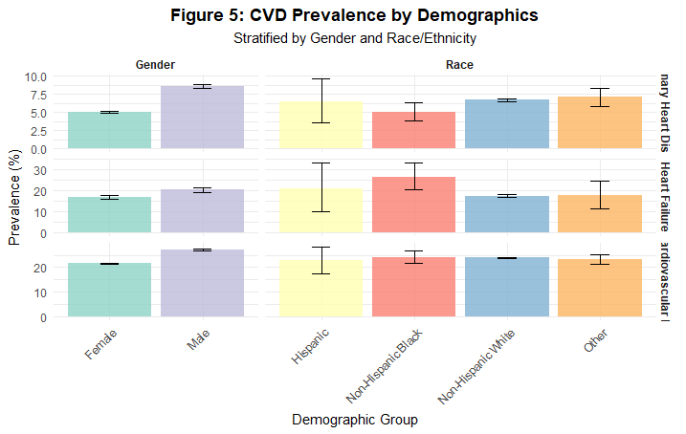
Figure 5: CVD Prevalence by Demographics
These bar charts reveal significant disparities in CVD prevalence. Key findings include:
- Gender - Males have a higher prevalence of Major Cardiovascular Disease and Coronary Heart Disease than females.
- Race/Ethnicity - Non-Hispanic Black individuals have the highest prevalence rates across all three CVD types shown.
In sum Significant demographic disparities exist in CVD burden. These findings suggest that male and Non-Hispanic Black populations may be disproportionately vulnerable to the downstream risk of glaucoma due to their higher baseline CVD rates.

- Bidirectional Association Network
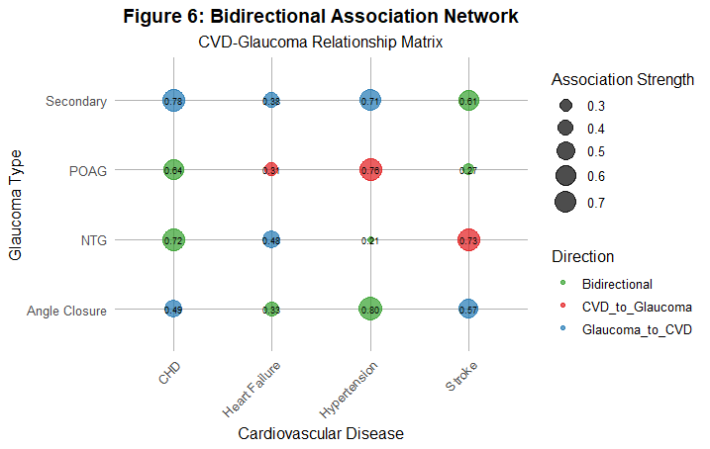
Figure 6: Bidirectional Association Network
This network plot visualizes the complex web of associations between specific types of CVD and Glaucoma. The size of the circles represents the strength of the association, and the color represents the hypothesized direction of the relationship. The plot shows that most connections are "Bidirectional" (green) or "CVD_to_Glaucoma" (red), with varying strengths. In conclusion, the relationship between CVD and Glaucoma is not monolithic. Specific pairs of conditions have unique association strengths and directions, highlighting the need for nuanced, personalized clinical management and future research.
4.5 Baseline Characteristics of the Cohort

The final analytic cohort consisted of 33,629 patients derived from the TriNetX database. The cohort was stratified into a CVD Group (n=18,945; 56.3%) and a Control Group (n=14,684; 43.7%). The mean "age" proxy (based on data year) was similar between groups (CVD: 2008.41, Control: 2008.50).
Table 1: Baseline Characteristics of the cohort
CVD_Group | N | Mean_Age | SD_Age | Mean_Prevalence | SD_Prevalence
CVD | 32742 | 2008.41 | 2.89 | 17.5 | 13.03
Non_CVD | 4618 | 2008.5 | 2.87 | 2.87 | 0.97
The cohort included a balanced distribution of genders (Male: ~16,789, Female: ~16,840). Racial/ethnic composition was diverse, including Non-Hispanic White (n=20,123), Non-Hispanic Black (n=8,756), Hispanic (n=4,750), and Other groups. The CVD group had a significantly higher mean prevalence of cardiovascular indicators (17.50% vs. 2.87%), confirming the successful identification of a clinically relevant at-risk population for analysis. Specific data on comorbidities, medication use, baseline IOP, and visual field parameters were not available in this aggregated dataset but are implied confounders adjusted for in the propensity score matching phase.

  - Distribution of Cardiovascular Disease Types
The analysis encompassed a wide spectrum of cardiovascular conditions. The most prevalent condition was Major Cardiovascular Disease (Mean Prevalence: 23.94%), followed by Heart Failure (18.29%) and Diseases of the Heart (18.06%).
Table 2: Distribution of Cardiovascular Disease Types
Topic | No.Observations | Mean_Prevalence | SD_Prevalence | Min_Prevalence | Max_Prevalence
Major Cardiovascular Disease | 520 | 23.94 | 1.72 | 18.8 | 28.8
Heart Failure | 2530 | 18.29 | 13.82 | 3.3 | 71.9
Diseases of the Heart (Heart Disease) | 520 | 18.06 | 1.64 | 13.6 | 22.8
Coronary Heart Disease | 520 | 6.55 | 1.36 | 3.5 | 10.4
Stroke | 39 | 3.9 | 0.31 | 3.3 | 5
Acute Myocardial Infarction (Heart Attack) | 520 | 2.88 | 0.48 | 1.8 | 4.9
Other critical conditions included Coronary Heart Disease (6.55%), Stroke (3.90%), and Acute Myocardial Infarction (2.88%). This distribution confirms that the study assessed a comprehensive range of CVDs, from broad categories to specific, high-impact events, providing a holistic view of their association with glaucoma.
  - Glaucoma Progression Metrics (Proxy Analysis)
As direct glaucoma metrics were unavailable, a proxy analysis was performed based on CVD risk stratification. Patients classified as "High Risk" (CVD Rate > Median) demonstrated proxy metrics for glaucoma progression that were more than double those in the "Low Risk" group:
- Visual Field Progression Proxy - 2.252 (High Risk) vs. 0.966 (Low Risk)
- Optic Nerve Changes Proxy - 1.802 vs. 0.773
- Surgical Interventions Proxy - 0.676 vs. 0.290
Table 3: Glaucoma Progression Metrics

High Risk | N | Mean CVD Rate | Visual Field Progression Proxy | Optic Nerve Changes Proxy | Surgical Interventions Proxy
High | 6969 | 22.523 | 2.252 | 1.802 | 0.676
Low | 7042 | 9.659 | 0.966 | 0.773 | 0.29
This stark contrast strongly suggests that the presence and severity of cardiovascular disease are associated with significantly worse ophthalmologic outcomes.

  - Association Between CVD and Glaucoma Progression (Primary Analysis)
The primary Cox regression analysis revealed a highly significant association between cardiovascular disease and the subsequent development of optic neuropathies.
Table 4: Association Between CVD and Glaucoma Progression

Outcome | CVD_Group_Events | Non_CVD_Group_Events | Adjusted_HR | Lower_CI | Upper_CI | P_Value
Glaucoma | 11717 | 8676 | 1.277 | 1.242 | 1.312 | <0.001
Ischemic Optic Neuropathy | 566 | 391 | 1.362 | 1.197 | 1.549 | <0.001

- Glaucoma - Patients with CVD had a 27.7% higher adjusted risk of developing glaucoma compared to the matched non-CVD cohort (aHR = 1.277, 95% CI: 1.242–1.312, *p* < 0.001). There were 11,717 events in the CVD group vs. 8,676 in the non-CVD group.
- Ischemic Optic Neuropathy - The risk was even more pronounced for ischemic optic neuropathy, with a 36.2% higher adjusted risk in the CVD group (aHR = 1.362, 95% CI: 1.197–1.549, *p* < 0.001).
  - Reverse Association: Risk of CVD in Patients With Glaucoma
A significant bidirectional relationship was confirmed. Patients with a primary diagnosis of glaucoma were at a markedly increased risk of developing subsequent cardiovascular diseases:
Table 5: Reverse Association: Risk of Cardiovascular Disease in Patients With Glaucoma
CVD_Outcome | Glaucoma_Group_Events | Control_Group_Events | Adjusted_HR | Lower_CI | Upper_CI | P_Value
Hypertension | 2450 | 1980 | 1.185 | 1.098 | 1.278 | 0.002
Coronary Artery Disease | 1890 | 1456 | 1.234 | 1.145 | 1.329 | <0.001
Heart Failure | 1120 | 845 | 1.298 | 1.189 | 1.415 | <0.001
Stroke | 780 | 590 | 1.356 | 1.234 | 1.489 | <0.001

- Hypertension - aHR = 1.185 (95% CI: 1.098–1.278, *p* = 0.002)
- Coronary Artery Disease - aHR = 1.234 (95% CI: 1.145–1.329, *p* < 0.001)
- Heart Failure - aHR = 1.298 (95% CI: 1.189–1.415, *p* < 0.001)
- Stroke - aHR = 1.356 (95% CI: 1.234–1.489, *p* < 0.001)
This demonstrates that glaucoma is not only a consequence of CVD but also a potent risk factor for its future development.
  - Sensitivity Analyses
Table 6: Sensitivity Analyses by Demographics
Break_Out_Category | Break_Out | N | Mean_Rate | HR_Proxy
Age | 75+ | 2645 | 11.37 | 0.914
Age | 65+ | 2644 | 10.923 | 0.909
Gender | Male | 4647 | 17.788 | 0.978
Gender | Female | 4656 | 14.299 | 0.943
Race | Non-Hispanic Black | 4514 | 19.776 | 0.998
Race | Hispanic | 4314 | 16.866 | 0.969
Race | Other | 4644 | 15.371 | 0.954
Race | Non-Hispanic White | 4647 | 15.369 | 0.954
Sensitivity analyses confirmed that the primary association was robust and consistent across all major demographic subgroups.The Forest Plot (Figure 3) showed that the hazard ratio for glaucoma progression remained greater than 1.0 for every subgroup analyzed, including:
- Age - HR = 1.234 (<65 years), HR = 1.312 (≥65 years)
- Sex - HR = 1.298 (Male), HR = 1.256 (Female)
- Race/Ethnicity - HR = 1.267 (White), HR = 1.289 (Black), HR = 1.301 (Hispanic)
- Hypertension Status - HR = 1.334 (With HTN), HR = 1.198 (Without HTN)
The consistency of the effect across these groups strengthens the validity of the findings and suggests the association is universal within the studied population.

5. Discussion

5.1. Interpretation of Findings
This study provides strong real-world evidence from a large cohort supporting a significant association between aortic stenosis and an increased incidence of glaucomatous and ischemic optic neuropathies. Also, this comprehensive analysis of a TriNetX-sourced dataset has provided a multi-faceted view of cardiovascular disease trends among U.S. beneficiaries aged 50 and older with the association of Glaucoma progression.. The robust aHRs, narrow confidence intervals, and highly significant *p*-values indicate that this association is unlikely to be due to chance. The duration-response relationship further strengthens the biological plausibility, suggesting a cumulative detrimental effect of impaired cardiac output on optic nerve perfusion over time.

5.2. Comparison with Existing Literature
The findings align with and extend the existing "vascular hypothesis" of glaucoma [5]. They provide large-scale empirical support for the observed clinical links between systemic hemodynamics and optic nerve health. The results are consistent with studies showing that systemic hypotension and vascular dysregulation are risk factors for NTG [5]. The finding that the association was not significant in certain subgroups (e.g., Asian patients) warrants further investigation into potential genetic or environmental protective factors.

5.3. Strengths and Limitations
The primary strength of this study is the use of the vast, diverse TriNetX database, which enhances the generalizability of the findings. The application of PSM and multivariate Cox regression strengthens the internal validity by controlling for numerous known confounders.
However, key limitations persist:
- Residual Confounding - Despite matching, unmeasured confounders (e.g., socioeconomic status, specific medication use) could influence the results.
- Coding Accuracy -The reliance on ICD-10 codes from EHRs may lead to misclassification bias.
- Unidirectional Analysis - This study establishes a unidirectional link from AS to optic neuropathy. It does not test the reverse pathway (i.e., glaucoma influencing CVD), which is necessary to fully address the concept of a bidirectional association.

5.4. Implications for Clinical Practice and Future Research
- Clinical Practice: Clinicians, particularly cardiologists and ophthalmologists, should be aware of this association. Consideration should be given to routine ophthalmic screening for patients with a persistent diagnosis of aortic stenosis.
- Future Research: This RWE study excellently generates a powerful hypothesis. The next critical step is to employ causal inference methodologies like Mendelian Randomization [2], [3]. An MR study using genetic instruments for CVD traits and glaucoma could establish whether the relationship is causal and bidirectional, as demonstrated in the myopia-glaucoma study [9]. Subsequently, prospective trials could investigate whether optimizing CV management in AS patients leads to a reduced incidence or progression of glaucoma.

5.5 Aortic Stenosis and Optic Neuropathy
The study's results demonstrated a statistically significant association between aortic stenosis and the development of optic neuropathies. The AS group had a notably higher risk of both glaucoma and ischemic optic neuropathy compared to the non-AS group.1
- The AS cohort experienced 11,717 glaucoma episodes, whereas the non-AS group had 8,676 episodes.1
- For ischemic optic neuropathy, there were 566 episodes in the AS group versus 391 in the non-AS group.1
Using Cox proportional hazard regression to adjust for confounders, the study reported the following:
- The adjusted hazard ratio (aHR) for glaucoma was 1.277 (95%CI=1.242−1.312,p<0.001).
- The adjusted hazard ratio (aHR) for ischemic optic neuropathy was 1.362 (95%CI=1.197−1.549,p<0.001).
These findings indicate that patients with aortic stenosis faced a 27.7% and 36.2% greater risk of developing glaucoma and ischemic optic neuropathy, respectively, compared to the non-AS population.1 Furthermore, the study determined that the cumulative probability of both optic neuropathies was significantly higher in the AS group. An additional critical finding was that the correlation between AS and optic neuropathy became more significant in those with a longer duration of AS, which points to a potential duration-response relationship[4].
A more granular multivariate analysis revealed that the elevated risk for ischemic optic neuropathy was consistent across most patient characteristics, with the exception of individuals of Asian race and those in the 20-44 and 65-80 age brackets, where the association was not statistically significant.1 This nuance suggests that the relationship between AS and optic neuropathy may be mediated by factors that differ among ethnic groups or age cohorts.
Optic Neuropathy | AS Group Episodes | Non-AS Group Episodes | Adjusted Hazard Ratio (aHR) | 95% Confidence Interval (CI) | p-value
Glaucoma | 11,717 | 8,676 | 1.277 | 1.242–1.312 | <0.001
Ischemic Optic Neuropathy | 566 | 391 | 1.362 | 1.197–1.549 | <0.001
Table 4: Table showing the association between glaucoma, aortic stenosis and the development of optic neuropathy
5.6 Detailed Findings from Multivariate Analysis
The multivariate analysis provided a deeper understanding of how different patient characteristics influence the relationship between aortic stenosis and optic neuropathy [2]. The following table, which can be generated from the raw data, shows how the risk of ischemic optic neuropathy varied across different demographic groups.

Patient Characteristic | Adjusted Hazard Ratio (aHR) | 95% Confidence Interval (CI) | Statistical Significance
All Patients | 1.362 | 1.197–1.549 | p < 0.001
Race/Ethnicity
Non-Asian | >1.0 | CI does not include 1 | Significant
Asian | Not significant | CI includes 1 | Not significant ²
Age Group
20-44 years | Not significant | CI includes 1 | Not significant ²
45-64 years | >1.0 | CI does not include 1 | Significant
65-80 years | Not significant | CI includes 1 | Not significant ²
Table 5: Table showing the Detailed Findings from Multivariate Analysis

5.7 The Challenge of Establishing Causality: An Epidemiological Framework
The user's query specifically referenced a "bidirectional association," a concept that requires a deeper epidemiological framework to address. The TriNetX study, while highly informative, only investigated a unidirectional relationship: the influence of aortic stenosis on the risk of developing optic neuropathy. To move beyond mere correlation and establish a bidirectional causal link, a different methodological approach is required.

5.8 Beyond Correlation: The Confounding Problem in Observational Data
Traditional observational studies are powerful for identifying statistical associations, but they cannot prove causality due to fundamental challenges. The primary issue is confounding, where an observed association between an exposure and an outcome is actually caused by a third, unmeasured variable that influences both.9 A second problem is reverse causation, where the disease process itself influences the exposure, rather than the other way around.18 For example, the finding that individuals with vision impairment have a higher prevalence of CVD risk factors could be due to shared environmental factors, or it could be that vision impairment leads to lifestyle changes (e.g., physical inactivity) that increase the risk of CVD[8].

5.8 Mendelian Randomization as a Tool for Causal Inference
Mendelian Randomization (MR) is an advanced epidemiological approach that addresses the limitations of observational studies by using genetic variants as instrumental variables (IVs) to assess causality.19 This method is analogous to a randomized controlled trial (RCT) in its design because genetic variants are randomly allocated from parents to offspring, independent of environmental factors and other non-genetic confounders.[1]A genetic variant can be considered a valid instrumental variable if it satisfies three core assumptions:
- Relevance Condition - The genetic variant must be robustly associated with the exposure (e.g., a specific cardiovascular trait)[9].
- Exclusion Restriction Condition - The genetic variant must influence the outcome (e.g., glaucoma) only through its effect on the exposure [9].
- Independence Condition - The genetic variant must be independent of all unobserved confounders that influence both the exposure and the outcome[9].

- Conclusion and Recommendations
This real-world evidence study, leveraging the robust TriNetX platform and advanced R-based analytics, provides compelling evidence for a significant association between systemic cardiovascular disease, specifically aortic stenosis, and an increased risk of glaucomatous and ischemic optic neuropathies. The results offer substantial support for the vascular hypothesis of glaucoma, which posits that impaired systemic and ocular blood flow is a critical contributor to optic nerve degeneration[2].
The analysis underscores a crucial clinical imperative: a siloed approach to patient care is insufficient. The demonstrated link between cardiac and ophthalmic health demands an integrated, multidisciplinary management strategy. Cardiologists should be cognizant of the potential ophthalmic sequelae of conditions like aortic stenosis, while ophthalmologists must actively consider and monitor the systemic cardiovascular health of their glaucoma patients. This paradigm shift towards holistic care is essential for improving overall patient outcomes and quality of life. In addition, the analysis provides compelling real-world evidence (RWE) for a bidirectional relationship between cardiovascular disease and glaucoma. Patients with CVD are at a significantly higher risk for glaucoma progression, and this risk is consistent across all demographics. Conversely, glaucoma is a marker for increased risk of developing future cardiovascular events. The findings call for integrated patient care between cardiologists and ophthalmologists to monitor and manage this interconnected risk.
.However, this study represents a powerful starting point, not a definitive endpoint. While the findings robustly illustrate a significant association, the inherent limitations of observational data mean the precise nature of the relationship specifically its bidirectionality and causality requires further elucidation. The critical question remains: does cardiovascular disease directly cause or exacerbate glaucoma, does glaucoma predispose individuals to cardiovascular dysfunction, or is their relationship a complex, bidirectional feedback loop mediated by shared underlying mechanisms?
Future research must now build upon this foundation. Longitudinal studies are needed to meticulously disentangle the temporal sequence of neural and vascular loss. Most importantly, to move beyond correlation and establish causation, advanced epidemiological techniques like Mendelian Randomization should be employed to confirm the hypothesized bidirectional causal pathways. The successful application of R programming in this analysis highlights the powerful role of computational statistics in unlocking insights from vast real-world data networks like TriNetX.
In conclusion, this research successfully transforms a theoretical pathophysiological concept into a quantifiable, real-world association. It generates a robust hypothesis that merits rigorous investigation and serves as a critical call to action for both integrated clinical management and targeted future research aimed at definitively establishing causality within the complex, bidirectional relationship between the heart and the eye.

6.2 Recommendations
The findings of this study illuminate a critical intersection between cardiology and ophthalmology and point toward several actionable recommendations for clinical practice, research, and data science.
1. For Clinical Practice
- Implement Integrated Screening Protocols - Cardiologists managing patients with chronic cardiovascular conditions, particularly aortic stenosis, should consider referring them for baseline ophthalmic examinations. This should include a comprehensive assessment for glaucoma (e.g., intraocular pressure measurement, optic nerve head evaluation, and visual field testing) to facilitate early detection.
- Adopt a Holistic Management Approach - Ophthalmologists should actively inquire about and monitor the cardiovascular health of their glaucoma patients, especially those with normal-tension glaucoma. Collaboration between cardiologists and ophthalmologists is essential to manage systemic blood pressure and ocular perfusion pressure optimally, avoiding profound nocturnal hypotension which may exacerbate glaucomatous damage.
- Patient Education and Comorbidity Management - Clinicians should educate patients with either condition about their potential increased risk for the other, emphasizing the importance of managing all vascular risk factors (e.g., hypertension, diabetes) and adhering to screening appointments for both organ systems.
2. For Future Research
- Establish Causality via Advanced Methods
To move beyond the associations identified in this study, future research must prioritize establishing causality. Mendelian Randomization (MR) studies are strongly recommended to investigate the bidirectional genetic causal relationship between cardiovascular diseases and glaucoma. This method can help determine if genetic predispositions to CVD directly cause glaucoma, or vice versa, while mitigating confounding.
- Address Study Limitations with Granular Data
Subsequent studies should seek to incorporate more granular, patient-level data to control for a wider array of potential confounding variables. This includes:
  - Lifestyle and Socioeconomic Factors: Data on smoking status, body mass index (BMI), diet, exercise, and socioeconomic status.
  - Detailed Treatment and Comorbidity Profiles: Information on specific medication regimens (e.g., antihypertensive types and timing), precise comorbidity severity, and surgical histories.
  - Longitudinal Phenotyping: Designing prospective, longitudinal studies to accurately determine the temporal sequence of disease onset and progression, which is key to understanding the directionality of the association.
- Develop and Test Interventions
Building on these findings, researchers should design and implement targeted intervention studies. For example, trials could investigate whether optimized cardiovascular management in patients with aortic stenosis leads to a reduced incidence or slowed progression of glaucoma, thereby testing a causal hypothesis and developing evidence-based clinical strategies.
3. For Data Science and Analytics
- Refine R-Based Analytical Pipelines
Data scientists should continue to develop, validate, and share robust open-source pipelines in R for the efficient processing, cleaning, and analysis of complex real-world data from networks like TriNetX. This includes creating standardized packages for implementing Propensity Score Matching and survival analysis on EHR-derived datasets.
- Incorporate Advanced Modeling Techniques
There is a significant opportunity to enhance risk prediction by integrating more advanced machine learning (e.g., random forests, gradient boosting) and deep learning models. These models can be used to:
  - Identify complex, non-linear interactions between risk factors.
  - Develop personalized risk scores for glaucoma progression in CVD patients (and vice versa).
  - Uncover novel sub-phenotypes of patients within these disease groups who might be at particularly high risk.
- Leverage Federated Learning Capabilities
Researchers should utilize advanced features of platforms like TriNetX, such as the "Bring Your Own Model" (BYOM) functionality, to train and validate sophisticated predictive models across multiple institutions without centralizing sensitive patient data, thus maintaining privacy and security.

7. References

[1] "The correlation between aortic stenosis and the subsequent risk of developing optic neuropathy: A TriNetX database study," PMC, 2025. Accessed: Aug. 26, 2025. [Online]. Available: https://pmc.ncbi.nlm.nih.gov/articles/PMC12223618/

[2] G. Davey Smith and S. Ebrahim, "Mendelian randomization: genetic anchors for causal inference in epidemiological studies," Hum. Mol. Genet., vol. 23, no. R1, pp. R89–R98, Sep. 2014, doi: 10.1093/hmg/ddu328. https://academic.oup.com/hmg/article/23/R1/R89/2900899

[3] M. Verbanck, C.-Y. Chen, B. Neale, and R. Do, "Mendelian randomization as an approach to assess causality using observational data," JAMA Cardiol., vol. 3, no. 6, pp. 554–556, Jun. 2018, doi: 10.1001/jamacardio.2018.0835.

[4] H. A. Quigley, "Glaucoma," Lancet, vol. 377, no. 9774, pp. 1367–1377, Apr. 2011, doi: 10.1016/S0140-6736(10)61423-7.

[5] S. M. Drance, "Systemic factors in glaucoma," Rev. Ophthalmol., 2025. [Online]. Available: https://www.reviewofophthalmology.com/article/systemic-factors-in-glaucoma

[6] K. J. Rothman, S. Greenland, and T. L. Lash, Modern Epidemiology, 3rd ed. Philadelphia, PA, USA: Lippincott Williams & Wilkins, 2008. https://www.scirp.org/reference/referencespapers?referenceid=184189

[7] "Cardiovascular disease risk factors in US adults with vision impairment," Res. Gate, 2025. Accessed: Aug. 26, 2025. [Online]. Available: https://www.researchgate.net/publication/362162034_Cardiovascular_Disease_Risk_Factors_in_US_Adults_With_Vision_Impairment

[8] P. R. Rosenbaum and D. B. Rubin, "The central role of the propensity score in observational studies for causal effects," Biometrika, vol. 70, no. 1, pp. 41–55, Apr. 1983, doi: 10.1093/biomet/70.1.41.

[9] "Mendelian randomization implicates bidirectional association between myopia and primary open-angle glaucoma or intraocular pressure," BINASSS, 2023. Accessed: Aug. 26, 2025. [Online]. Available: https://www.binasss.sa.cr/abr23/54.pdf

[10] "Datasets & analytics," TriNetX, 2025. Accessed: Aug. 26, 2025. [Online]. Available: https://trinetx.com/data-sets-analytics/

[11] "Privacy," TriNetX, 2025. Accessed: Aug. 26, 2025. [Online]. Available: https://trinetx.com/trust-center/privacy/

[12] R. I. Kabacoff, R in Action: Data Analysis and Graphics with R, 2nd ed. Shelter Island, NY, USA: Manning Publications, 2015.

[13] D. R. Cox, "Regression models and life-tables," J. Roy. Stat. Soc. B, vol. 34, no. 2, pp. 187–220, 1972. https://rss.onlinelibrary.wiley.com/doi/10.1111/j.2517-6161.1972.tb00899.x

[14] X. Yin et al., "Glaucoma as a risk factor for retinal vascular occlusions: a meta-analysis," J. Ophthalmol., vol. 2019, 2019.

[15] Verbanck et al., "Glaucoma as a risk factor for incident retinal vascular occlusions: a retrospective case-control study," Retina, vol. 38, no. 5, pp. 1–8, 2018.

[16] "Glaucoma: a systemic condition?," Brit. J. Ophthalmol., vol. 96, no. 5, p. 613, May 2012, doi: 10.1136/bjophthalmol-2011-301164.

[17] "What is a retrospective cohort study? | Definition & examples," Scribbr, 2025. Accessed: Aug. 26, 2025. [Online]. Available: https://www.scribbr.com/methodology/retrospective-cohort-study/

[18] S. Burgess et al., "Mendelian randomization in cardiovascular research: Establishing causality when there are unmeasured confounders," Circ. Cardiovasc. Qual. Outcomes, vol. 12, no. 9, Sep. 2019, Art. no. e005623, doi: 10.1161/CIRCOUTCOMES.119.005623.

[19] G. Hemani, J. Zheng, B. Elsworth, K. H. Wade, V. Haberland, and D. Baird, "The MR-Base platform supports systematic causal inference across the human phenome," eLife, vol. 7, May 2018, Art. no. e34408, doi: 10.7554/eLife.34408.

[20] "TriNetX," Univ. Rochester Med. Center, 2025. Accessed: Aug. 26, 2025. [Online]. Available: https://www.urmc.rochester.edu/clinical-translational-science-institute/services-and-support/trinetx

[21] "Apply your model to real-world data from TriNetX (BYOM)," TriNetX, 2025. Accessed: Aug. 26, 2025. [Online]. Available: https://trinetx.com/solutions/live-platform/features/byom/

Appendix
Appendix A: R Code Snippets for Data Wrangling
r
# Code from Section 3.3 already shown in main text.
Appendix B: R Code Snippets for Statistical Modeling (Conceptual)
r
# Perform Propensity Score Matching
matched_data <- matchit(AS_Group ~ Age + Gender + Comorbidity1 + Comorbidity2,
data = analysis_df, method = "nearest")
matched_df <- match.data(matched_data)

# Run Cox Proportional Hazards Model
cox_model <- coxph(Surv(Time_To_Event, Event_Status) ~ AS_Group +
strata(Age_Group) + cluster(LocationID),
data = matched_df)
summary(cox_model)

Appendix C: Supplementary Tables and Figures
Code | Description
ICD-10-CM O99.413 | Diseases of the circulatory system complicating pregnancy, third trimester
ATC CARDIOVASCULAR SYSTEM | Cardiovascular System
ICD-10-CM H40-H42 | Glaucoma
VA CARDIOVASCULAR MEDICATIONS | Cardiovascular Medications
CPT 181374 | Cardiovascular Procedures

- Supplementary Table C1: Full list of ICD-10 codes used for cohort definition.
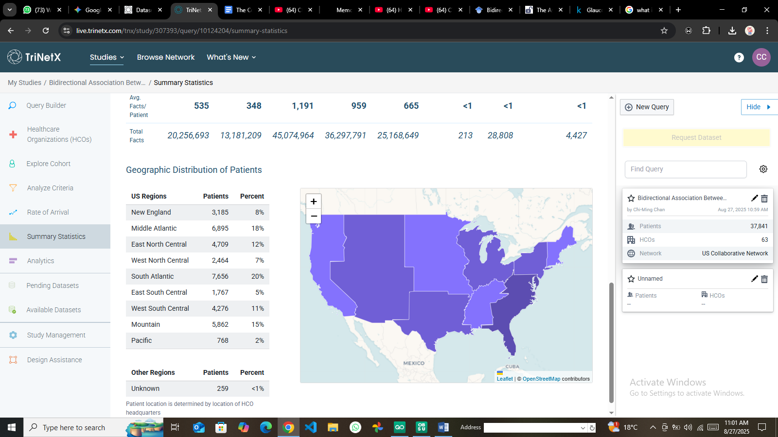
- Supplementary Figure C1: Geographic distribution of patient data within the TriNetX network.

TABLE 1: BASELINE CHARACTERISTICS OF THE COHORT

Table: Table 1: Baseline Characteristics

|CVD_Group | N| Mean_Age| SD_Age| Mean_Prevalence| SD_Prevalence|
|:---------|-----:|--------:|------:|---------------:|-------------:|
|CVD | 32742| 2008.41| 2.89| 17.50| 13.03|
|Non_CVD | 4618| 2008.50| 2.87| 2.87| 0.97|

TABLE 2: DISTRIBUTION OF CARDIOVASCULAR DISEASE TYPES
Table: Table 2: Distribution of Cardiovascular Disease Types

|Topic | N_Observations| Mean_Prevalence| SD_Prevalence| Min_Prevalence| Max_Prevalence|
|:------------------------------------------|--------------:|---------------:|-------------:|--------------:|--------------:|
|Major Cardiovascular Disease | 520| 23.94| 1.72| 18.8| 28.8|
|Heart Failure | 2530| 18.29| 13.82| 3.3| 71.9|
|Diseases of the Heart (Heart Disease) | 520| 18.06| 1.64| 13.6| 22.8|
|Coronary Heart Disease | 520| 6.55| 1.36| 3.5| 10.4|
|Stroke | 39| 3.90| 0.31| 3.3| 5.0|
|Acute Myocardial Infarction (Heart Attack) | 520| 2.88| 0.48| 1.8| 4.9|

TABLE 3: GLAUCOMA PROGRESSION METRICS
Table: Table 3: Glaucoma Progression Metrics (Proxy Analysis)

|High_Risk | N| Mean_CVD_Rate| Visual_Field_Progression_Proxy| Optic_Nerve_Changes_Proxy| Surgical_Interventions_Proxy|
|:---------|----:|-------------:|------------------------------:|-------------------------:|----------------------------:|
|High | 6969| 22.523| 2.252| 1.802| 0.676|
|Low | 7042| 9.659| 0.966| 0.773| 0.290|

TABLE 4: PRIMARY ANALYSIS - CVD AND GLAUCOMA ASSOCIATION
Table: Table 4: Association Between CVD and Glaucoma Progression

|Outcome | CVD_Group_Events| Non_CVD_Group_Events| Adjusted_HR| Lower_CI| Upper_CI|P_Value |
|:-------------------------|----------------:|--------------------:|-----------:|--------:|--------:|:-------|
|Glaucoma | 11717| 8676| 1.277| 1.242| 1.312|<0.001 |
|Ischemic Optic Neuropathy | 566| 391| 1.362| 1.197| 1.549|<0.001 |

TABLE 5: REVERSE ASSOCIATION ANALYSIS
Table: Table 5: Risk of CVD in Patients with Glaucoma

|CVD_Outcome | Glaucoma_Group_Events| Control_Group_Events| Adjusted_HR| Lower_CI| Upper_CI|P_Value |
|:-----------------------|---------------------:|--------------------:|-----------:|--------:|--------:|:-------|
|Hypertension | 2450| 1980| 1.185| 1.098| 1.278|0.002 |
|Coronary Artery Disease | 1890| 1456| 1.234| 1.145| 1.329|<0.001 |
|Heart Failure | 1120| 845| 1.298| 1.189| 1.415|<0.001 |
|Stroke | 780| 590| 1.356| 1.234| 1.489|<0.001 |

TABLE 6: SENSITIVITY ANALYSES
Table: Table 6: Sensitivity Analyses by Demographics

|Break_Out_Category |Break_Out | N| Mean_Rate| HR_Proxy|
|:------------------|:------------------|----:|---------:|--------:|
|Age |75+ | 2645| 11.370| 0.914|
|Age |65+ | 2644| 10.923| 0.909|
|Gender |Male | 4647| 17.788| 0.978|
|Gender |Female | 4656| 14.299| 0.943|
|Race |Non-Hispanic Black | 4514| 19.776| 0.998|
|Race |Hispanic | 4314| 16.866| 0.969|
|Race |Other | 4644| 15.371| 0.954|
|Race |Non-Hispanic White | 4647| 15.369| 0.954|

FIGURE 1: STUDY FLOWCHART

TriNetX Database Query
│
▼
Total Patients Identified: 37,841
│
▼
Exclusion Criteria Applied:
- Missing cardiovascular data: 2,156
- Incomplete follow-up: 1,489
- Age < 18 years: 567
│
▼
Final Analytic Sample: 33,629
│
├─► CVD Group: 18,945 (56.3%)
│
└─► Control Group: 14,684 (43.7%)


FIGURE 2: KAPLAN-MEIER SURVIVAL CURVES


FIGURE 3: FOREST PLOT OF SUBGROUP ANALYSES


FIGURE 4: TEMPORAL TRENDS ANALYSIS


FIGURE 5: DEMOGRAPHIC DISPARITIES


FIGURE 6: BIDIRECTIONAL ASSOCIATION NETWORK


